Lab Report

By: Tyler Schmidt and Marc Pepperman

1. Introduction

In this lab we were given many small codes to create and design to show what we have learned in the first two weeks of our Python class. The codes had us use if/else statements, lists, libraries specific to python, classes and the use of anaconda. In this report I will be covering the code and how we created it. Hopefully, by the end of this report you will have a better understanding of Python and uses of the program.

1. Objective

The objective we had was to complete six codes of varying length and difficulty.

Description of code:

1. For any web application login, the user password need to be validated against database rules.
2. Write a Python function that accepts a sentence of words from user and display the following:

a. Middle word

b. Longest word in the sentence

c. Reverse all the words in sentence

1. Given a list of n number, write a Python program to find triplets in the list which gives the sum of zero.
2. Consider the following scenario. You have a list of students who are attending class "Python" and another list of students who are attending class "Web Application".

Find the list of students who are attending both the classes. Also find the list of students who are not common in both the classes. Print the both lists.

1. Write a python program to create any one of the following management systems we chose the hotel reservation.
2. Using NumPy create random vector of size 15 having only Integers in the range 0-20. Write a program to find the most frequent item/value in the vector list

1. Approaches/Methods
2. We created a if statement that would check to see if password is true. We then had a for loop that would check to make sure it had the proper format such as capital letter, lower case letter, a digit and a character. If inputted properly the code would return successful if not it would ask for you to re-enter.
3. This was a tricky one for us. We ended up going with a if/else statement to get the middle word. We then used a for statement that that would reverse the letters and get the largest word.
4. We used a Python library called itertools that allowed us to use a combination. With the combination we were able to create a set and the combination would find the numbers that we needed to get 0.
5. This one was tricky but after looking at it longer I realized it was really easy. All I had to do was create a set to which I was then able to use characters to find people in both classes and people that are just in one.
6. We chose the hotel program. This code has a parent class and child classes. There is a total of 5 classes. The first class is to get information from the guest then the child classes will go through and find out more specific things. Such as bed size, room type, getting an upgraded room and information regarding the trip.
7. In this code we used another python library called numpy from there we were able to create an array of 15 number between 0 and 20. After we had that created all we had to do was make a while loop that will find the largest frequency in the array.
8. Workflow

The workflow for this project was strictly done over the course of the past week. We would communicate with each other on some problems if we had issues and didn’t understand something. For the most part we did all the problems on our own but decided to only turn in the ones that were the best and had proper code etiquette. We would meet when possible and have also created a server chat system for us to share code more easily.

1. Datasets(if applicable)

N/A

1. 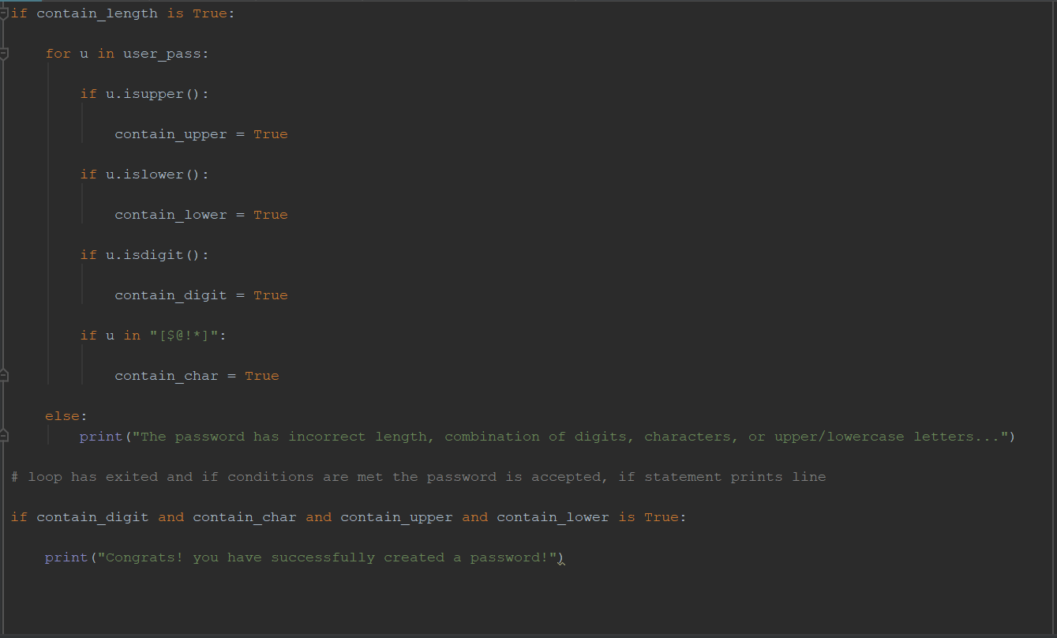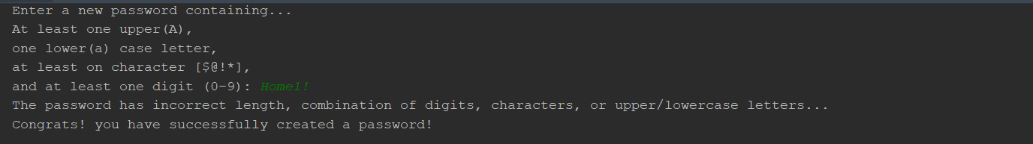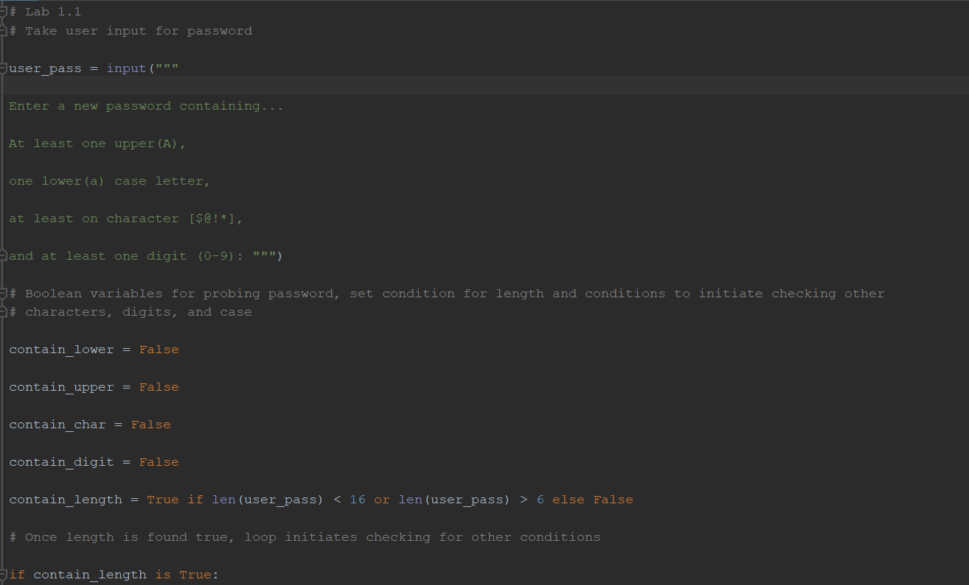Parameters

Problem 1: Results

Problem 1: Code

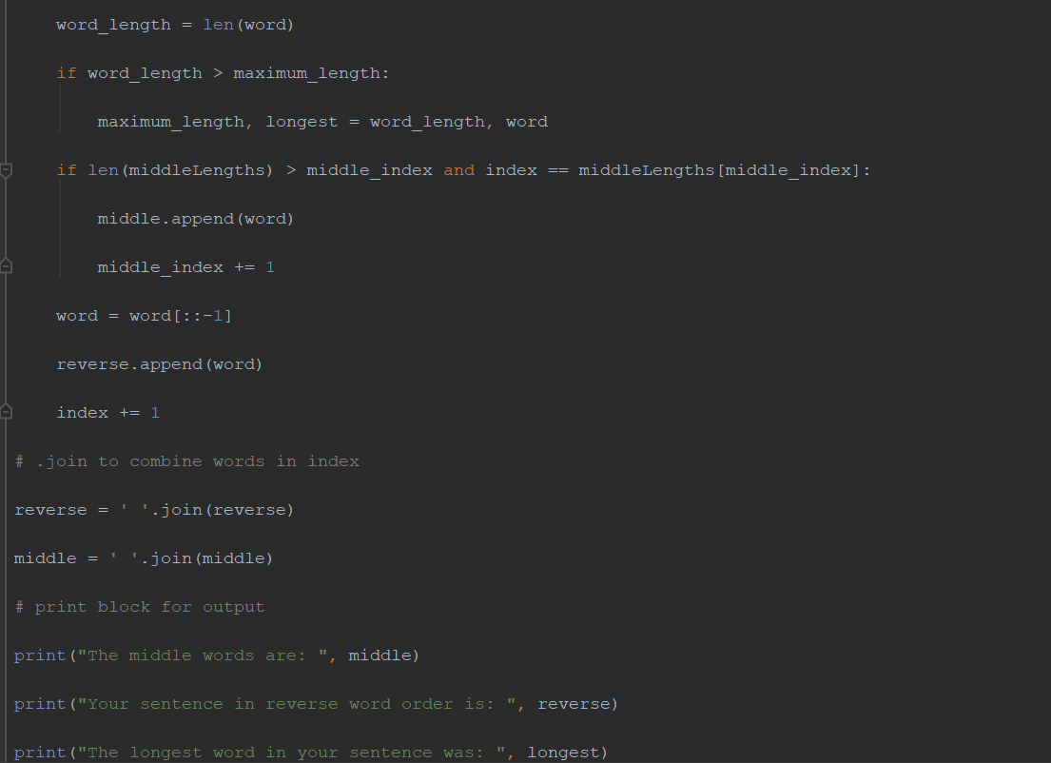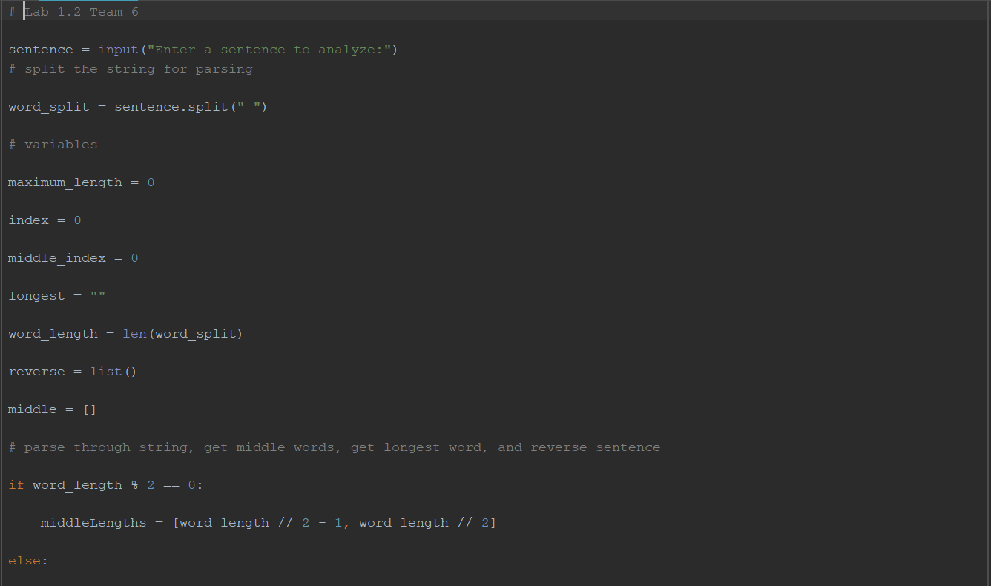

Problem 2: Results

Problem 2: Code

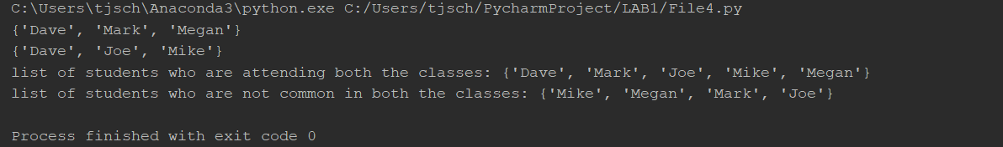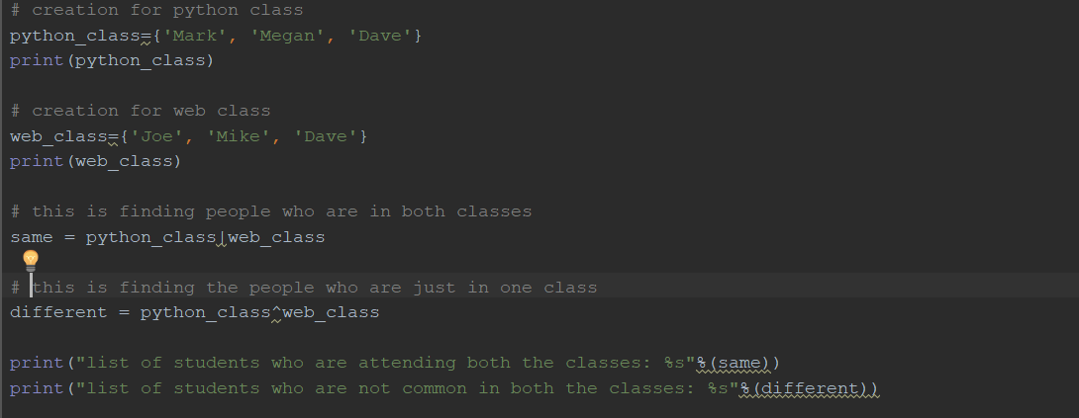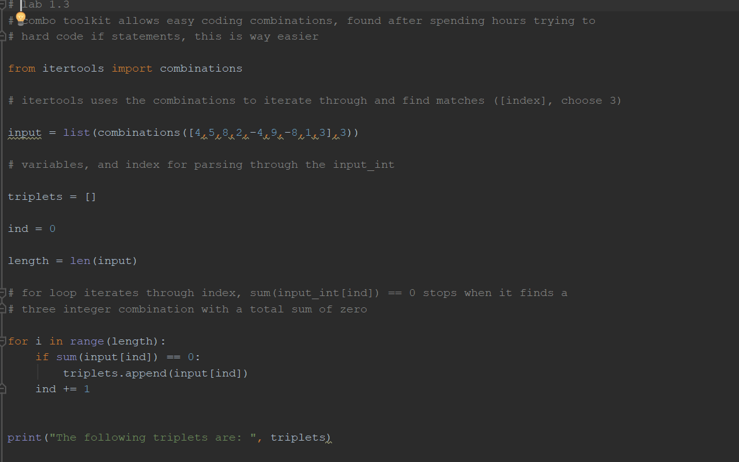

Problem 4: Results

Problem 4: Code

Problem 3: Results

Problem 3: Code

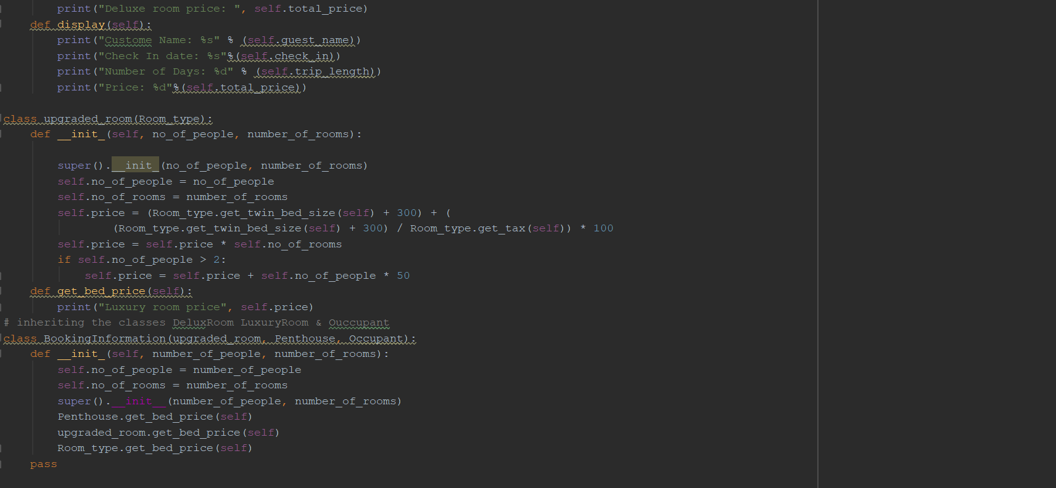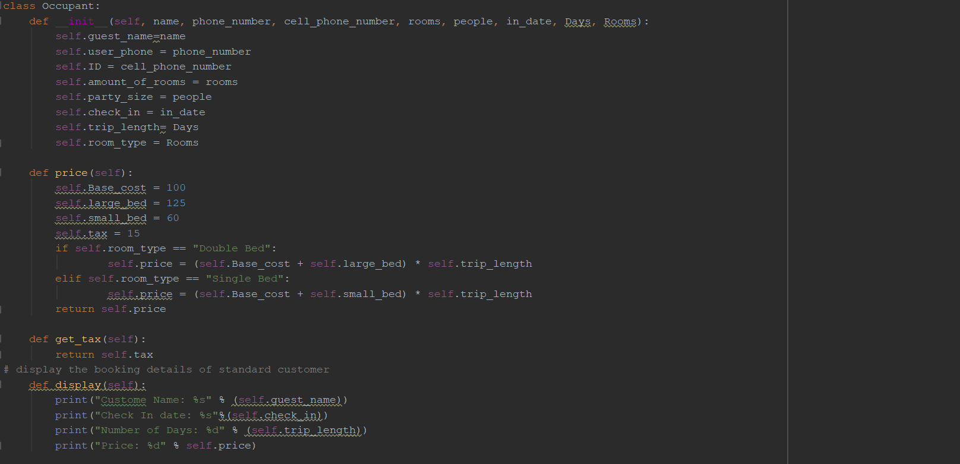

Problem 5: Code

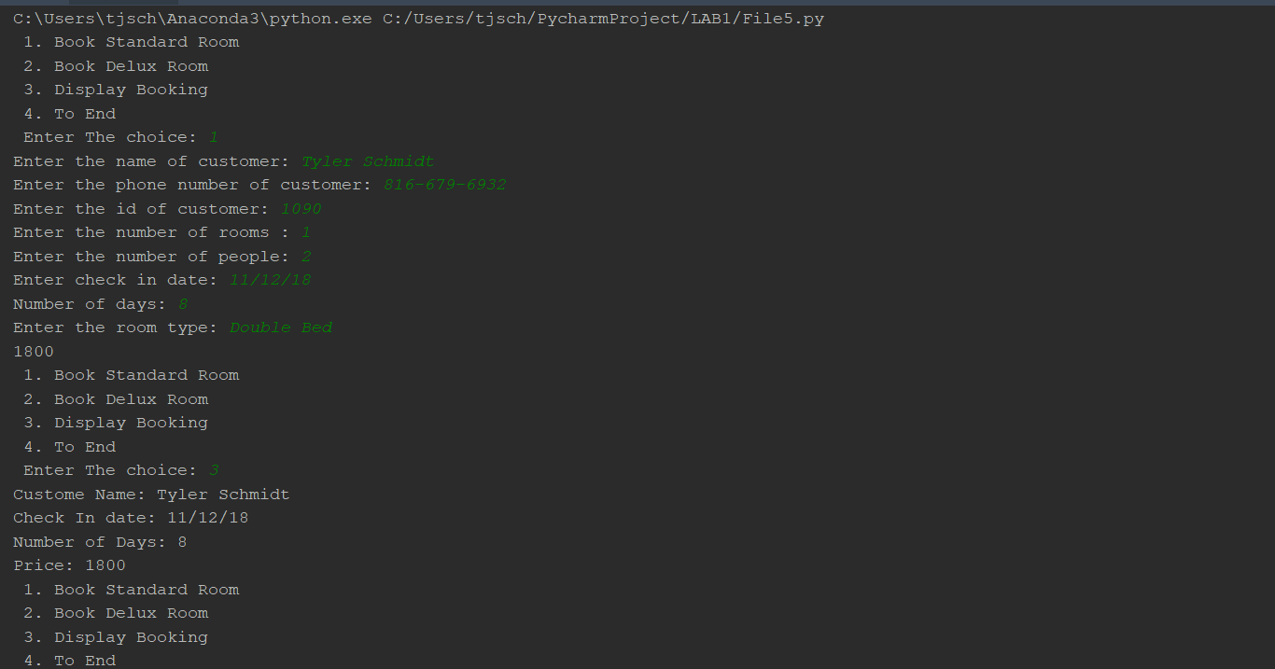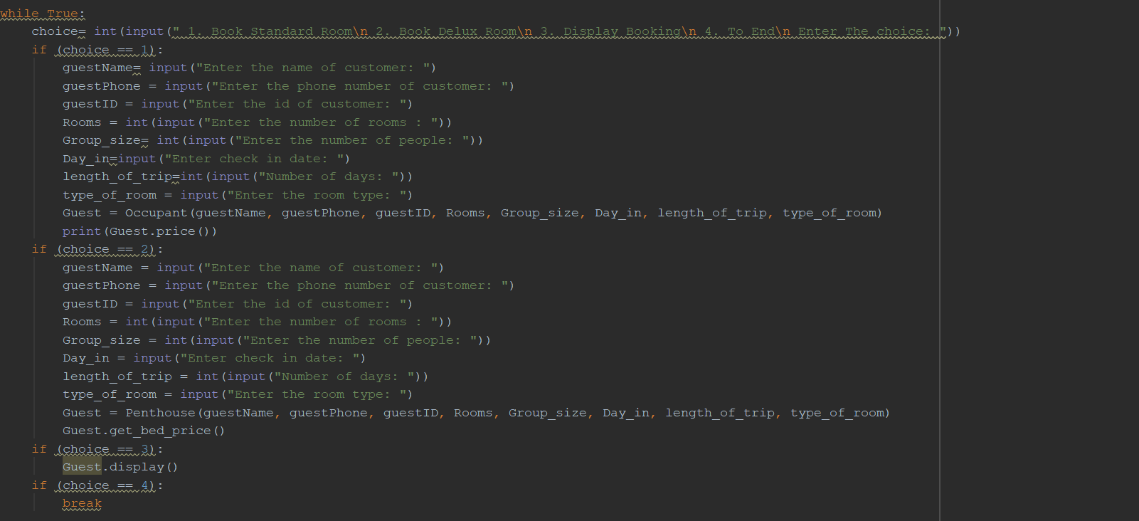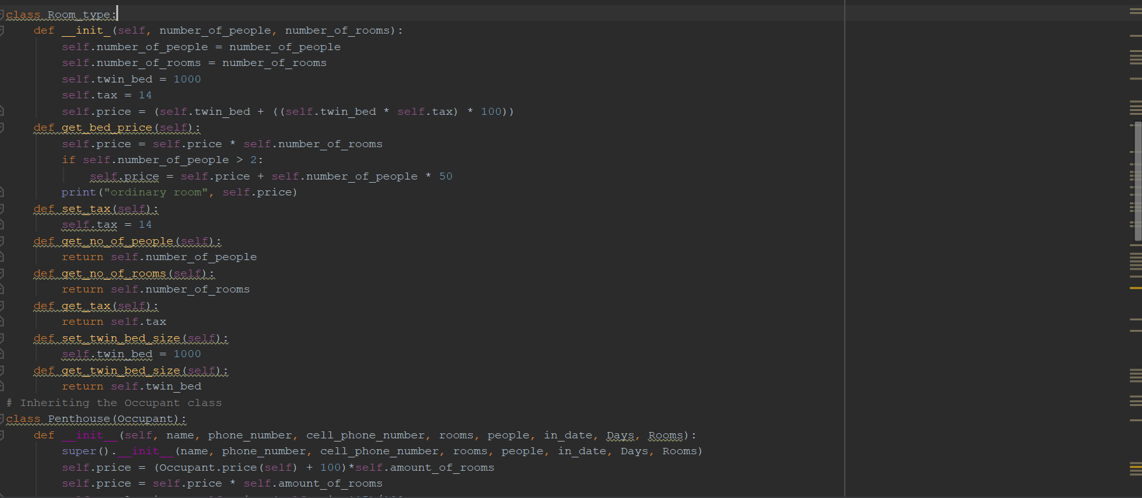

Problem 5: Results

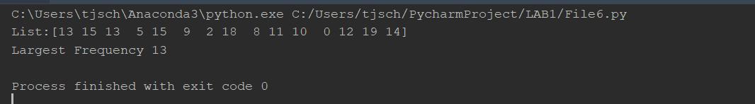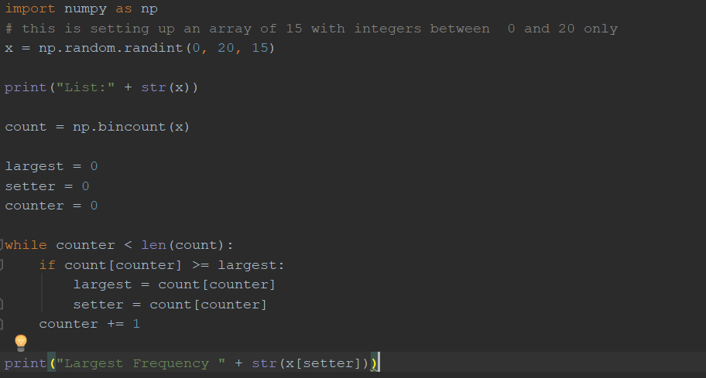

Problem 6: Results

Problem 6: Code

1. Evaluation & Discussion

All the problems run and do what they are supposed to. We have carefully commented our code and made sure it was formatted properly. The codes did take longer than what we expected and some were challenging. I do believe that we could of created better and more efficient code on a couple of the problems.

1. Conclusion

Overall, I feel that the lectures and in class programs have helped my team member and I complete the lab. I am excited to continue to learn more about Python and hopefully continue to create stronger code. All requirements were met for this Lab.